**Module 4 – DBMS Assessment Task**

* Write SQL query to solve the problem given below

Consider three table named as city, customer and country

The city table is given below :

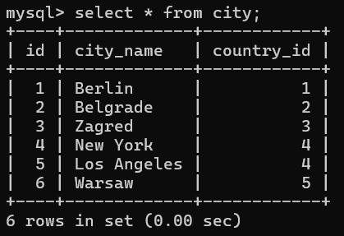

The Customer table :

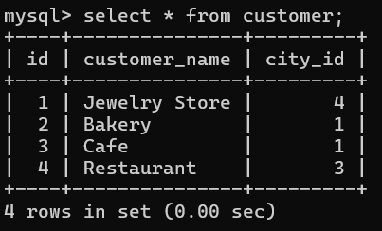

The Country table :

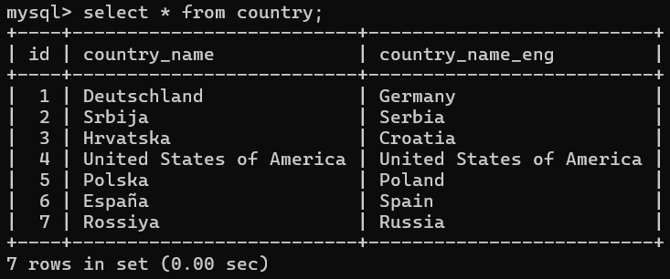

**Task : 1 (join multiple tables using left join)**

* List all Countries and customers related to these countries.
* For each country displaying its name in English, the name of the city customer is located in as well as the name of the customer.
* Return even countries without related cities and customers.

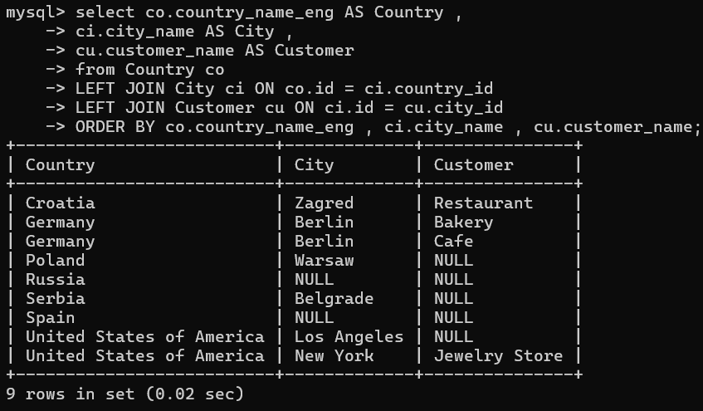

**Task : 2 (join multiple tables using both left and inner join)**

* Return the list of all countries that have pairs(exclude countries which are not referenced by any city). For such pairs return all customers.
* Return even pairs of not having a single customer

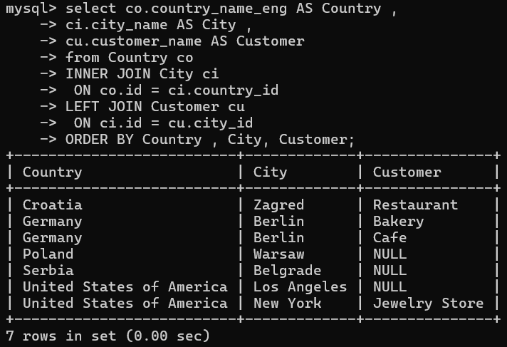

**Serbia, Los Angeles, Warsaw** appear **even without customers** ✅

Countries without any city (like Spain, Russia) are **excluded** ✅